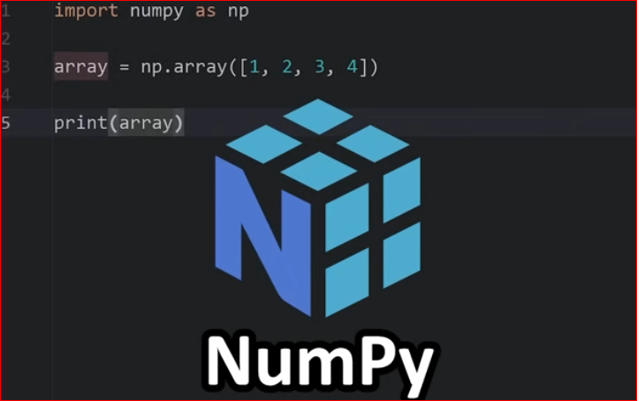
Introduction to NumPy
- NumPy = Numerical Python, a Python library for scientific computing.
  - ndarrays (n-dimensional arrays)
  - Mathematical & statistical functions
  - Linear algebra functions
  - Random number generation
- 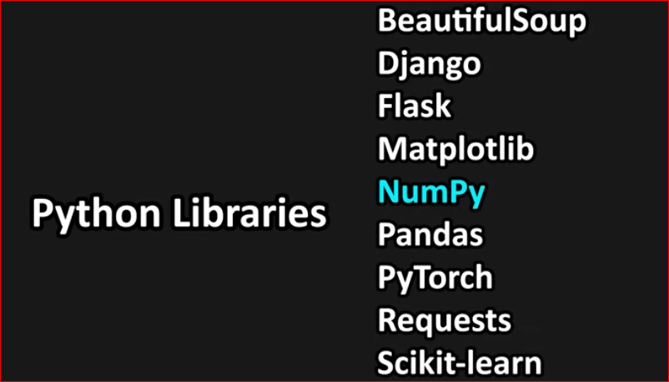

Numerical Python, a library for mathematical & scientific computing
Python lists are slow for large data, NumPy arrays are fast and memory-efficient
NumPy is the foundation for Pandas, Matplotlib, Scikit-learn


Python list = a stack of different books
NumPy array = a neatly arranged shelf of identical books → faster to search, sum, or manipulate
Always start with import numpy as np

NumPy can do math with big data much faster than normal Python lists.
quickly find sum, average, min, max, standard deviation etc. (just like Excel formulas).
can add, subtract, or multiply whole sets of numbers in one step instead of writing long loops.
can reshape, filter, and fix data easily before analyzing.
Popular libraries like Pandas, Scikit-learn, TensorFlow are built on NumPy.
NumPy = Fast math with arrays (good for calculations).
Pandas = Easy table handling (good for real datasets).
Pandas uses NumPy inside for speed.

1.NumPy Arrays (ndarray)
Array = grid of elements (all same type)
Can be 1D, 2D, 3D, … Nd
Used in data storage, ML inputs, image processing

What is a Dimension?
Dimension tells us how many indices you need to access an element in the array.
In simple words:
1D → 1 index
2D → 2 indices (row & column)
3D → 3 indices (row, column, depth)

Chain Indexing in NumPy

Chain indexing means accessing elements step by step using multiple square brackets.

array[index1][index2][index3]

NumPy: arange(), ones(), eye(),linspace()

arange() → creates array with step-based sequence
ones() → creates array filled with ones
eye() → creates identity matrix

np.arange() – Create numbers in a sequence

np.arange(start, stop, step)

np.ones() – Create array filled with 1s

np.ones(shape)

np.eye() – Identity Matrix

1 on the main diagonal
0 everywhere else
[[1. 0. 0. 0.]
[ 0. 1. 0. 0.]
[0. 0. 1. 0.]
[0. 0. 0. 1.]]

np.linspace() – Create evenly spaced numbers

np.linspace(start, stop, num)

np.linspace() is used when you need a fixed number of evenly spaced values between two limits.

Includes both start and stop
Returns float values
Used when exact number of points is required

np.random.rand()
👉 Uniform random numbers (0 to 1)

Generates random float values
Range: 0 ≤ value < 1
Follows uniform distribution

np.random.randn()
Random numbers from standard normal distribution
Meaning
Generates random float values
Mean = 0
Standard deviation = 1
Values can be negative or positive
Range is NOT fixed

np.random.randint()
👉 Random integers in a given range
Meaning
Generates random whole numbers
Lower bound = inclusive
Upper bound = exclusive

np.random.randint(low, high, size)

Function | Type | Range | Distribution | Output
rand() | Float | 0 to 1 | Uniform | Decimal
randn() | Float | Any value | Normal | Decimal
randint() | Integer | Given range | Uniform | Whole numbers
=======================
Array Attributes and Methods

Attribute | Meaning

ndim | Number of dimensions

shape | Rows & columns

size | Total elements

dtype | Data type

itemsize | Bytes per element

nbytes | Total memory

Reshaping arrays
Reshaping means changing the shape of an array.
The shape of an array is the number of elements in each dimension.
By reshaping we can add or remove dimensions or change number of elements in each dimension.

arr.shape shows
arr.shape returns the dimensions (shape) of the NumPy array.
It is a 1D array (vector)
It contains 5 elements
There is no column dimension

(For a vector, arr.shape returns a single value tuple like (n,), where n is the number of elements.)

NumPy treats vectors as 1D arrays
Row/column distinction exists only in 2D arrays

NumPy Array Indexing
Array indexing is the same as accessing an array element.
You can access an array element by referring to its index number.
The indexes in NumPy arrays start with 0, meaning that the first element has index 0, and the second has index 1 etc.

Slicing arrays
Slicing in python means taking elements from one given index to another given index.
We pass slice instead of index like this: [start:end].
We can also define the step, like this: [start:end:step].
If we don't pass start its considered 0
If we don't pass end its considered length of array in that dimension
If we don't pass step its considered 1

arr.copy() returns a deep copy of the NumPy array.
Changes made to the copied array do NOT affect the original array.

